

Speech and Language Therapist
(Part Time)

Start Date: Pending notice period/1st September 2026
Closing Date: 17th August 2026 at Midday
Interviews: Applications will be considered upon receipt. We reserve the right to interview and appoint at any stage of the process.
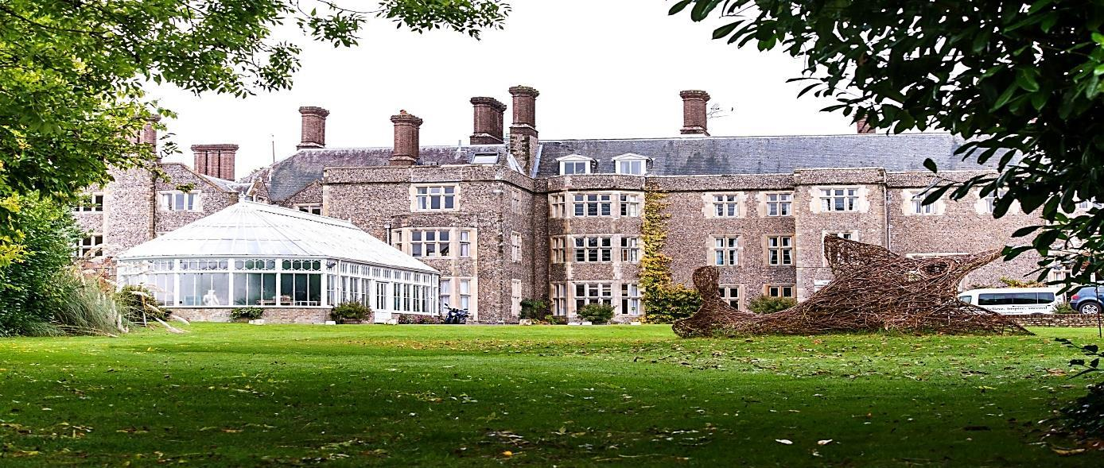

Headteacher: Sotiria Vlahodimou
Slindon House, Top Road, Slindon, Arundel, West Sussex BN18 0RH
Tel: 01243 814320 www.slindoncollege.co.uk



Job Title: Speech and Language Therapist (Part Time)

Pay: NHS Equivalent (pro rata) College Salary Scale:
SCT4 £27,193-SCT6 £46,087 per annum pending experience (Full
Time equivalent pro rata for days worked)
Pay review pending Sep 2026
Hours: Up to four days a week 34 weeks/year (Term Time only) 8:15am-4:30pm

Benefits: Group Personal Pension Plan, Meals and Refreshments on Duty during term time, Counselling Service, Cycle to Work Scheme, On-Site Parking, Personal Accident Insurance, Discretionary Annual Bonus Award, Fee Remission
Accountable To: SENCo
Probation Period: One Term
Contract: Permanent

Special Terms: Mandatory attendance at Sept INSET day (safeguarding)

This is an exciting opportunity for a qualified Speech and Language Therapist (SALT) to join our vibrant, friendly, positive and forward-looking team on a part time basis of up to four days per week. You will be joining a dynamic learning support team which includes Speech & Language Therapists, Occupational Therapists, Dyslexia specialists and intervention Learning Support Assistants (iLSAs). You will play an integral part in delivering the SaLT provision and working with our teachers/learning support assistants to support pupils and their parents/carers to achieve person-centered outcomes relevant to Education Health Care Plans. The ideal candidate will have experience of working with children and young people with a range of special educational needs within an educational setting.

Own transport is required as there is no public transport available.
Slindon College is committed to safeguarding and promoting the welfare of children and young people and expects all staff and volunteers to share this commitment. In addition to normal pre-employment checks, all appointments are subject to an enhanced Disclosure and Barring Service check and safeguarding interview. In addition, a Prohibition Order check, a Prohibition from Management check and overseas checks will be carried out for relevant positions.
All posts are exempt from the Rehabilitation of Offenders Act 1974 and the College is therefore permitted to ask job applicants to declare all convictions and cautions (including those which are ‘spent ‘unless they are ‘protected’ under the DBS filtering rules) in order to assess their suitability to work with children.

How to Apply
Please complete the Application Form including a supporting statement. CVs alone cannot be accepted. Your application can be submitted by email to hr@slindoncollege.co.uk.
We are happy to accommodate tours prior to application. Please contact the HR Officer to book.
GENERAL INFORMATION FOR APPLICANTS

The College

With unrivalled views of the south coast, the 14 acre setting provides the backdrop to a stimulating, broad and balanced specialist educational experience for boys with additional learning needs aged 8-18 of all academic abilities, taking into account their strengths and talents.
Currently we have approximately 110 pupils on roll, 9 of whom are boarders. Some 98% of our pupils progress to Further Education or Training. We are proud of our College’s strong links with the local community and employers which assist us in fully serving the needs of our pupils.
Slindon College employs a team of therapists who work closely with teachers and education staff to ensure pupils’ needs are met. We offer a wide and varied curriculum so that pupils, as well as achieving in core subjects, can experience a range of subjects and so choose those that best suit their interests and ability.

Slindon College won the 2024 Independent Schools Association Excellence and Innovation in Mental Health and Wellbeing Award. The school also holds the Carnegie Centre of Excellence for Mental Health in Schools Award (Silver).

Location
The College is situated in the South Downs National Park, nestled in the heart of the Slindon Village near the historic market town of Arundel. The nearest train stations are Barnham and Arundel.

Our Pupils
Our pupils thrive with some additional learning support as most have previously struggled to make progress in mainstream school settings. As a consequence, over a number of years, we have developed expertise in recognising obstacles to learning and putting in place learning pathways which help them to successfully re-engage with education.

Curriculum and Organisation
At KS2/3 all pupils study the National Curriculum. Pupils are grouped for learning in most subjects.
At KS4 pupils study a core consisting of English, Maths, Science, ICT, PE and PSHE. They are encouraged to take four of their option choices. Our facilities enable us to offer a range of vocational qualifications.
All subjects are expected to differentiate learning to meet the needs of the whole ability range and to provide extension activities for the gifted and talented. Additionally, the Learning Support Department provides excellent out-of-class and in-class support for pupils with a range of additional educational needs. Teachers are provided with detailed information on pupils’ strengths, needs, prior attainment and target grades. We are rigorous in applying our assessment for learning policy to ensure that all pupils make appropriate progress in line with national expectations.
Pupils’ welfare and educational progress are supervised by Heads of House who remain with the pupils as they progress through the College.

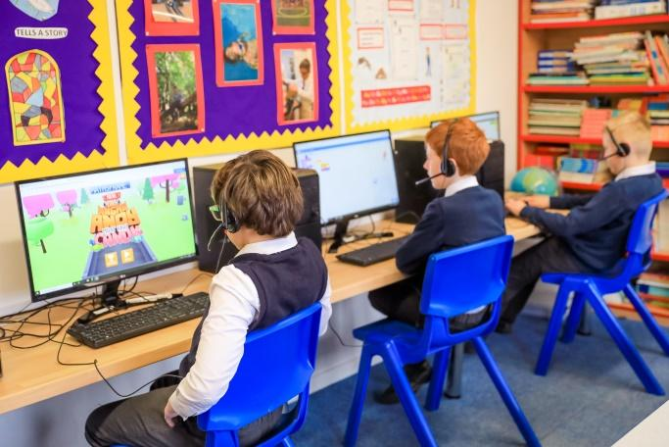



The Staff
The College working environment is stimulating and very busy but we do try to ensure there is opportunity for staff to meet together regularly; we hold briefings every morning and a weekly academic staff meeting. Lunch is provided for all staff members during term time when on duty.
Continuing Professional Development lies at the heart of our people first values in relation to staff, and we are proud that many colleagues actively seek further development and advance their careers within the College.

More Information
To find out more about Slindon College, please visit our website: www.slindoncollege.co.uk or find us on social media:

Facebook: SlindonCollege

Instagram: SlindonCollege

LinkedIn: Slindon-College

JOB DESCRIPTION
Job Purpose
To provide high-quality Speech and Language Therapy (SALT) service to a caseload of pupils with moderate Special Educational Needs (SEN) and oversee a team of Interventions Learning Support Assistants (iLSAs).

Duties and Responsibilities
Clinical
- To oversee a caseload of pupils with moderate SEN and be responsible for their SALT assessment and treatment. This includes:
- Providing appropriate SALT assessment, using standardised assessment where possible, and analysing clinical and social information from a range of sources to develop an appropriate treatment plan.
- Working alongside teaching staff to ensure the delivery of individualised SALT programmes that meet pupils’ needs.
- Seeing pupils individually and/or in groups as appropriate and providing suitable SALT as described in the EHCPs.
- To source appropriate resources to assist iLSAs to deliver intervention and to supervise iLSAs delivering appropriate individual and group sessions.
- To be responsible for meeting the Educational Health Care Plan (EHCP) SALT provision requirements for pupils with EHCPs.
- To regularly monitor and review the pupils’ ongoing communication needs.
- To act as the College SALT representative at multi-disciplinary meetings as required.
- To maintain and further develop a high level of clinical expertise in speech and language therapy.
- To liaise closely with all staff and parents/carers to support implementation of appropriate communication strategies.
- To be an effective member of the multidisciplinary team within Slindon College and to liaise regularly with your line manager regarding specific needs of the pupils.
- To have a good working knowledge of relevant procedures including Safeguarding Children, SEN procedures and other relevant legislation related to the health, education and social welfare of children/young people and their families.
- Maintain consistent high standards of professional conduct, tact and diplomacy at all times in dealings with pupils, parents, staff colleagues, external agencies and any other visitors to the school.
Administration
- To provide reports for the pupils’ EHCP annual review.
- To maintain records of intervention according to professional standards.
- To provide evidence and information as required for inspections or accreditations.
- To share information with others, observing information sharing and data protection guidelines.
- To contribute to development of information and advice for parents or carers through leaflets or on the school website.
- To autonomously manage own time and prioritise demands of caseload on a day-to-day basis.
Supervision and Training
- To maintain up to date Health Care Professional Councils (HCPC) registration.
- To develop and maintain the skills and knowledge required of a SALT working with children and young people with SEN.
- To receive regular supervision and demonstrate the ability to reflect on practice with peers and supervisor and identify own development needs.
- Take responsibility for keeping own knowledge and skills up to date by engaging in continuing professional development and maintaining a portfolio of CPD.
- To share new information with and provide SALT training/feedback to other staff.
- To participate in the in-house training sessions including all INSET days.
Supporting the College
- To service and maintain school notice boards, classroom and corridor displays.
- To provide an effective, courteous and professional interface between internal colleagues, pupil; the general public, parents and external bodies.
- To attend and participate in meetings, Parents’ Evenings, Parents’ Tea and two annual Open Mornings as required.

General Responsibilities
- Work at all times in a safe manner in consideration to the College risk assessments and to report all accidents to Matron in line with statutory requirements.
- Participate in training and other learning activities, performance and professional development as required.
- To participate in the supervision cycle according to the College policy.
- Contribute to the overall ethos/work/aims of Slindon College.
- Be aware of and comply with current legislation concerning, but not limited to, Equal Opportunities, Health & Safety at Work, Fire Safety. Be aware of and comply with the College’s policies and procedures relating to Child Protection/Safeguarding, health & safety, security, reporting all concerns to the appropriate person.
- To report any health and safety issues observed to your line manager, taking remedial action where possible to curtail risk.
- Undertake all duties reasonably requested in a manner consistent with the mission and aims of Slindon College.
Confidentiality
- The post holder must at all times maintain the complete confidentiality of the material and information that they handle.
- Maintain and record accurate information in line with Compliance, GDPR and Freedom of Information regulations.

This general job description is not comprehensive and the post holder will be required to undertake other tasks appropriate to the level of appointment as the Headteacher may reasonably require to ensure the efficient and effective running of the College.

PERSON SPECIFICATION
 | Essential |  | Desirable | Method of Assessment
Qualifications
Degree or equivalent Diploma in  Speech and Language Therapy. |  |  |  | Application
Member of RCSLT. |  |  |  | Application
Registration with the Health Care Professions Council (HCPC). |  |  |  | Application
Skills and Experience
Experience of working as part of a multi-disciplinary team. |  |  |  | Application/  Interview
Comprehensive knowledge of a wide range of speech, language and communication disabilities associated with children with SEN and Autism and their impact on learning. |  |  |  | Application
The knowledge of a range of therapeutic interventions relevant to the client group. |  |  |  | Application/  Interview
Previous experience of working within an educational setting with children or young people with SpLD. |  |  |  | Application
Clear and concise written skills with competency in IT skills to produce accurate and concise written records and reports. |  |  |  | Application/  Interview
Experience of providing specialist comprehensive written information to parents and other professionals. |  |  |  | Application/  Interview
Experience in preparing SALT reports to support Annual Reviews of EHCPs. |  |  |  | Application/  Interview
The ability to recognise and manage difference of opinion in both client related and inter-professional situations. |  |  |  | Application/  Interview
Knowledge of psychosocial aspects of working with families of children with SEN and the impact on the family. |  |  |  | Application/  Interview
Willingness to undertake continued professional development. |  |  |  | Application/  Interview
Personal Attributes
Ability to organise and prioritise workload. |  |  |  | Interview
Ability to work independently and collaboratively, with a range of professionals and statutory bodies. |  |  |  | Interview
Ability to deal in a polite, clear, sensitive and professional manner with all stakeholders. |  |  |  | Interview
Ability to reflect on clinical practice and experience. |  |  |  | Interview
A flexible calm and empathetic approach to dealing with children. |  |  |  | Interview
Willing to make a positive contribution to the wider life and ethos of the College. |  |  |  | Interview
Ability to maintain a high degree of confidentiality and to use discretion in dealing with sensitive information. |  |  |  | Application/  Interview
A commitment to safeguarding and promoting the welfare of children and young people. |  |  |  | Application/  Interview

